1. Agenda:
   1. We will create a Rest Template to send HTTP msg from where we will get some timeout and then caller will throw retryable exception so that msg can be recon sumed and retried again.
2. 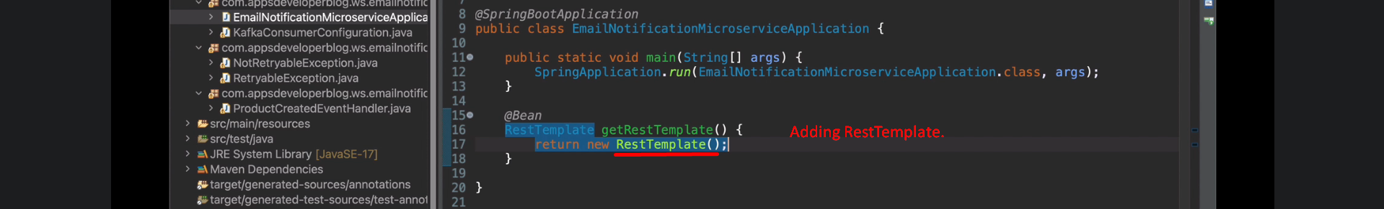
3. 